Assignment #1

By Dong Yan

5944970

February 04, 2021

**Part I Screenshot for all defects**

First defect, “Student ID” field allows to enter digits that less than or more than seven digits.

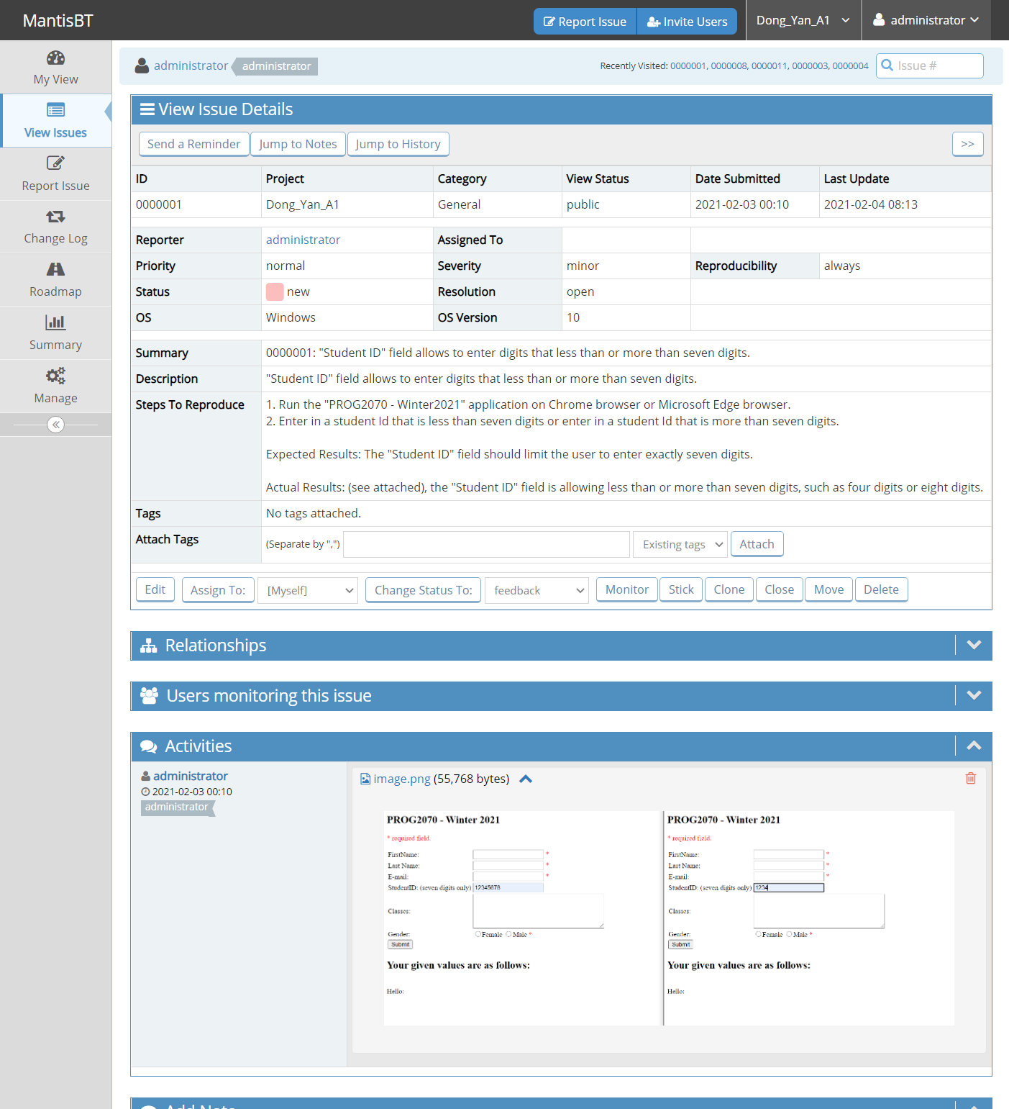

Second defect, “Student ID” field allows to enter non digital characters.

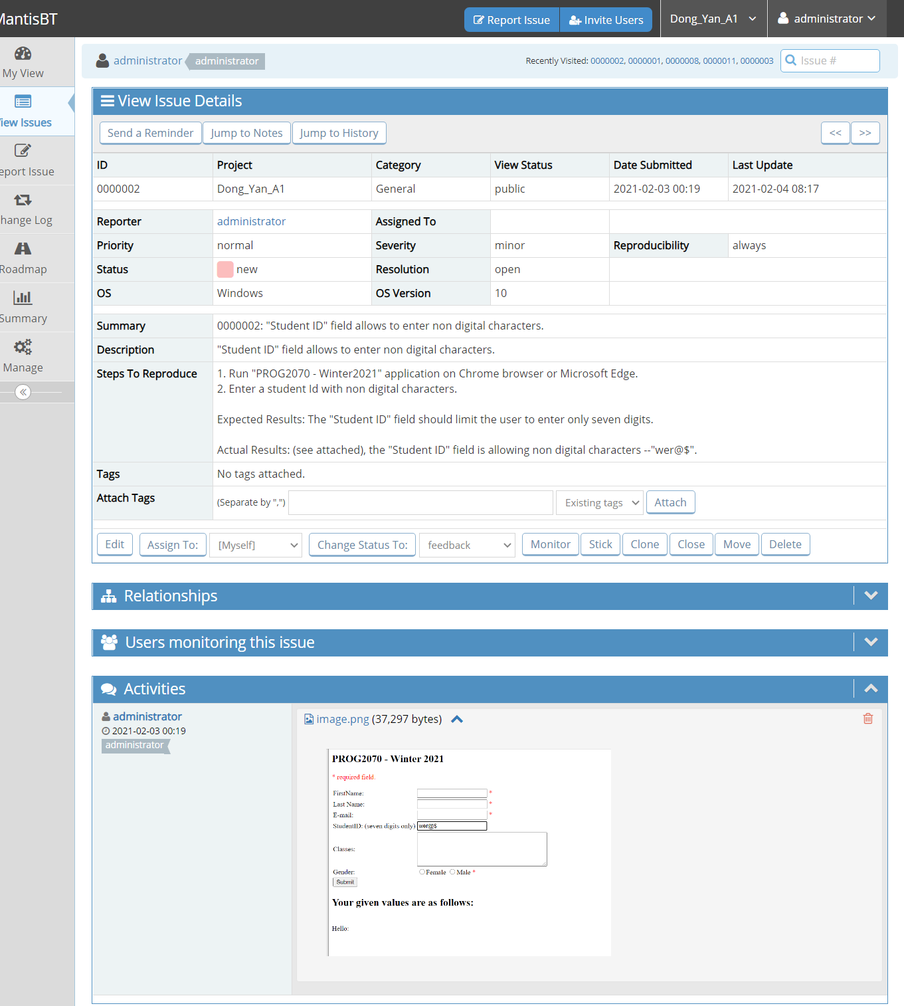

Third defect, "Submit" button doesn't return an error message for inputting invalid value in the "Student ID" field.

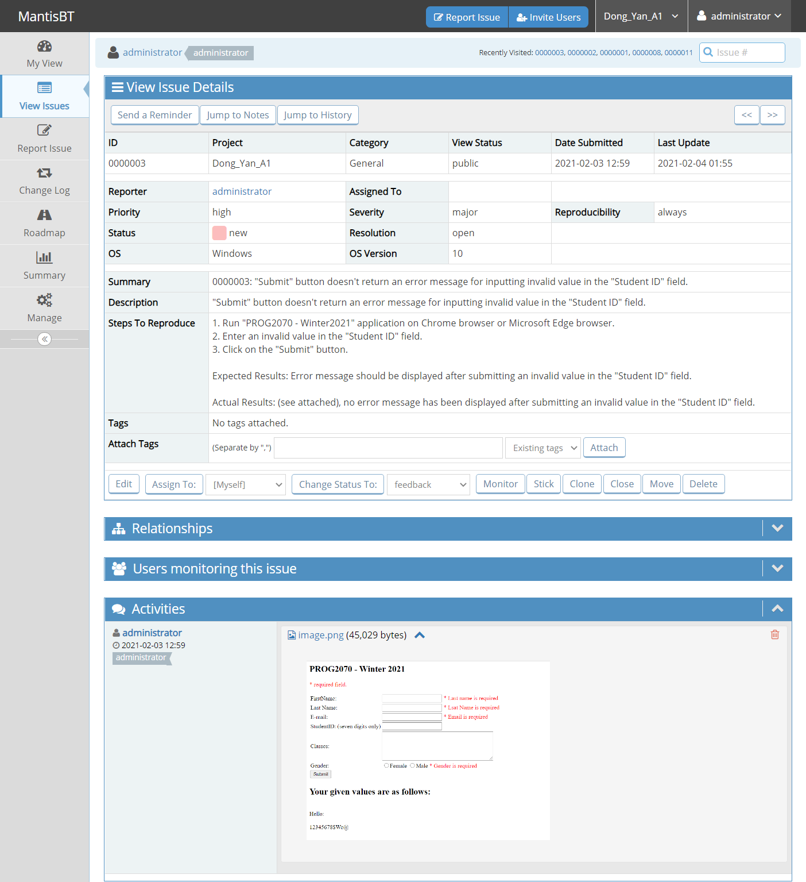

Fourth defect, typo is occurred in "Lsat Name is required" error message.

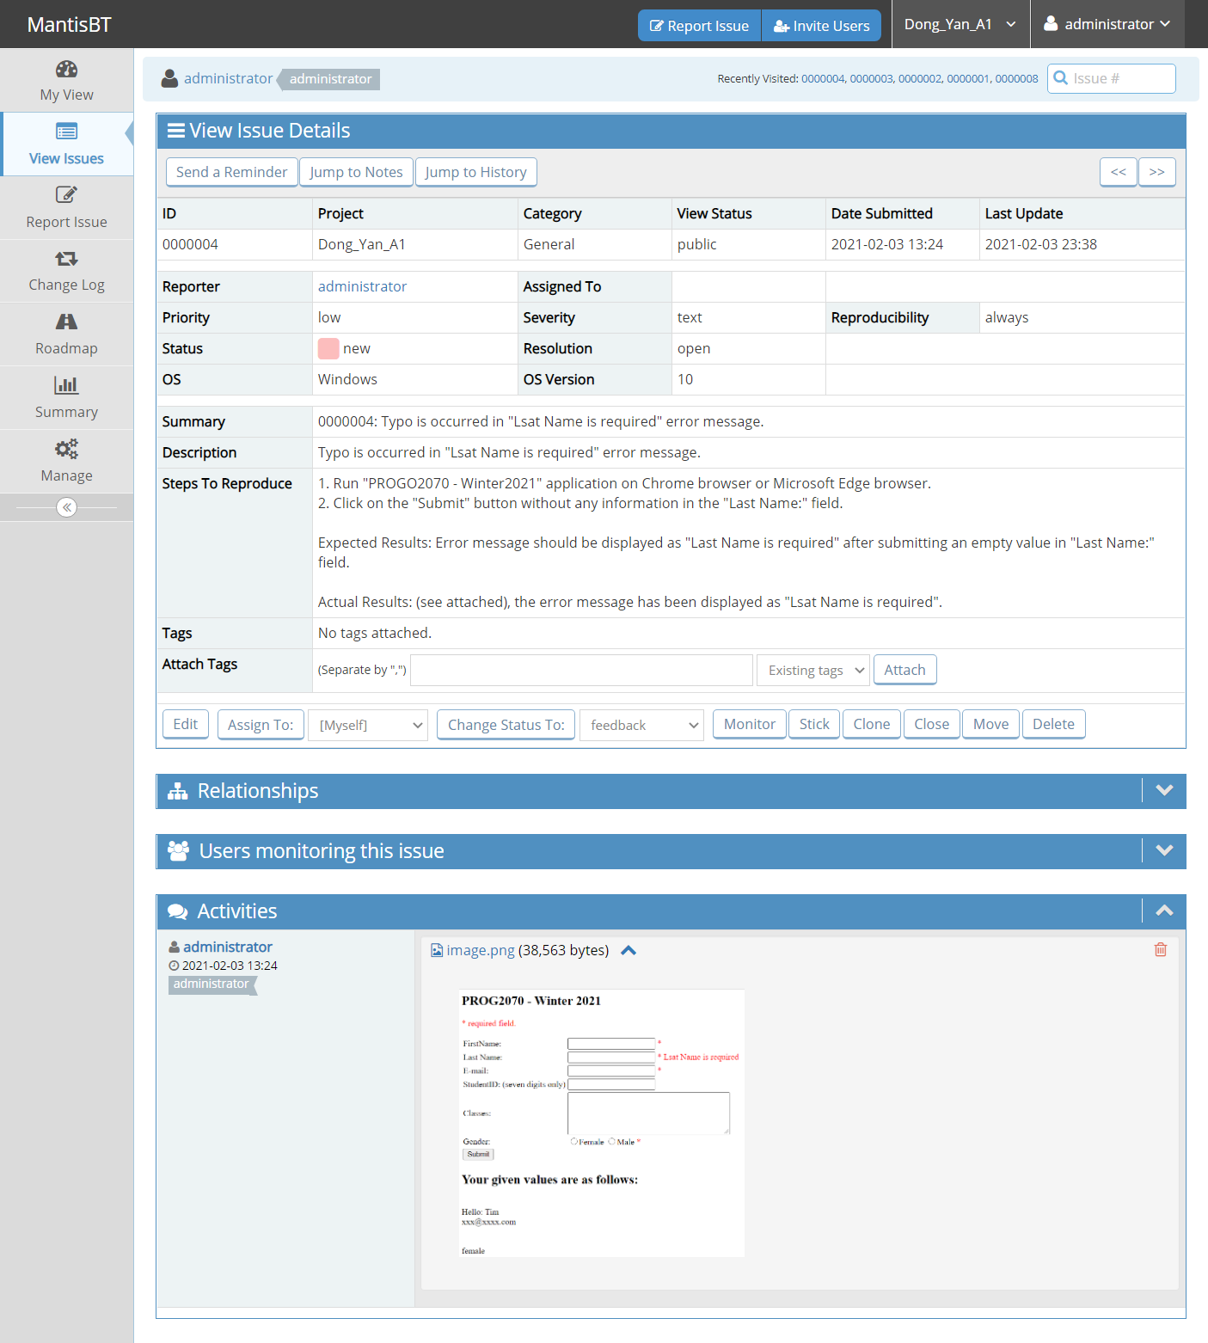

Fifth defect, when select a gender in "Gender" selection field, the output is opposite to input.

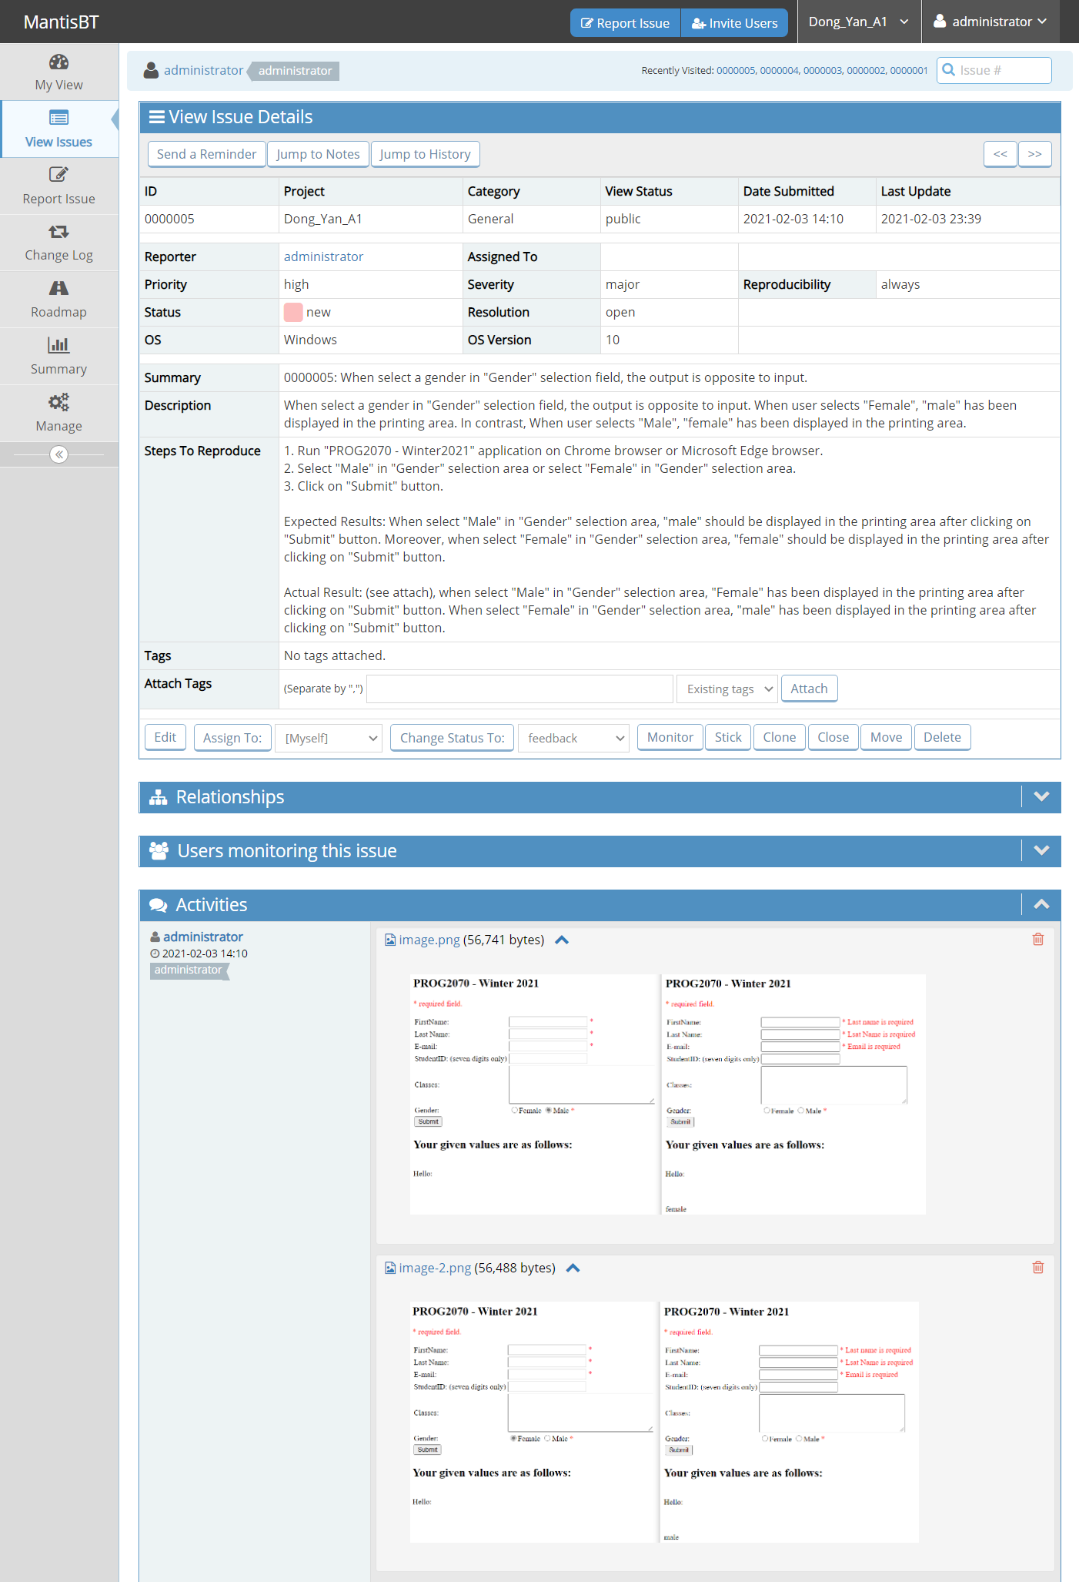

Sixth defect, typo is occurred in "StudentID: (seven digits only)" label.

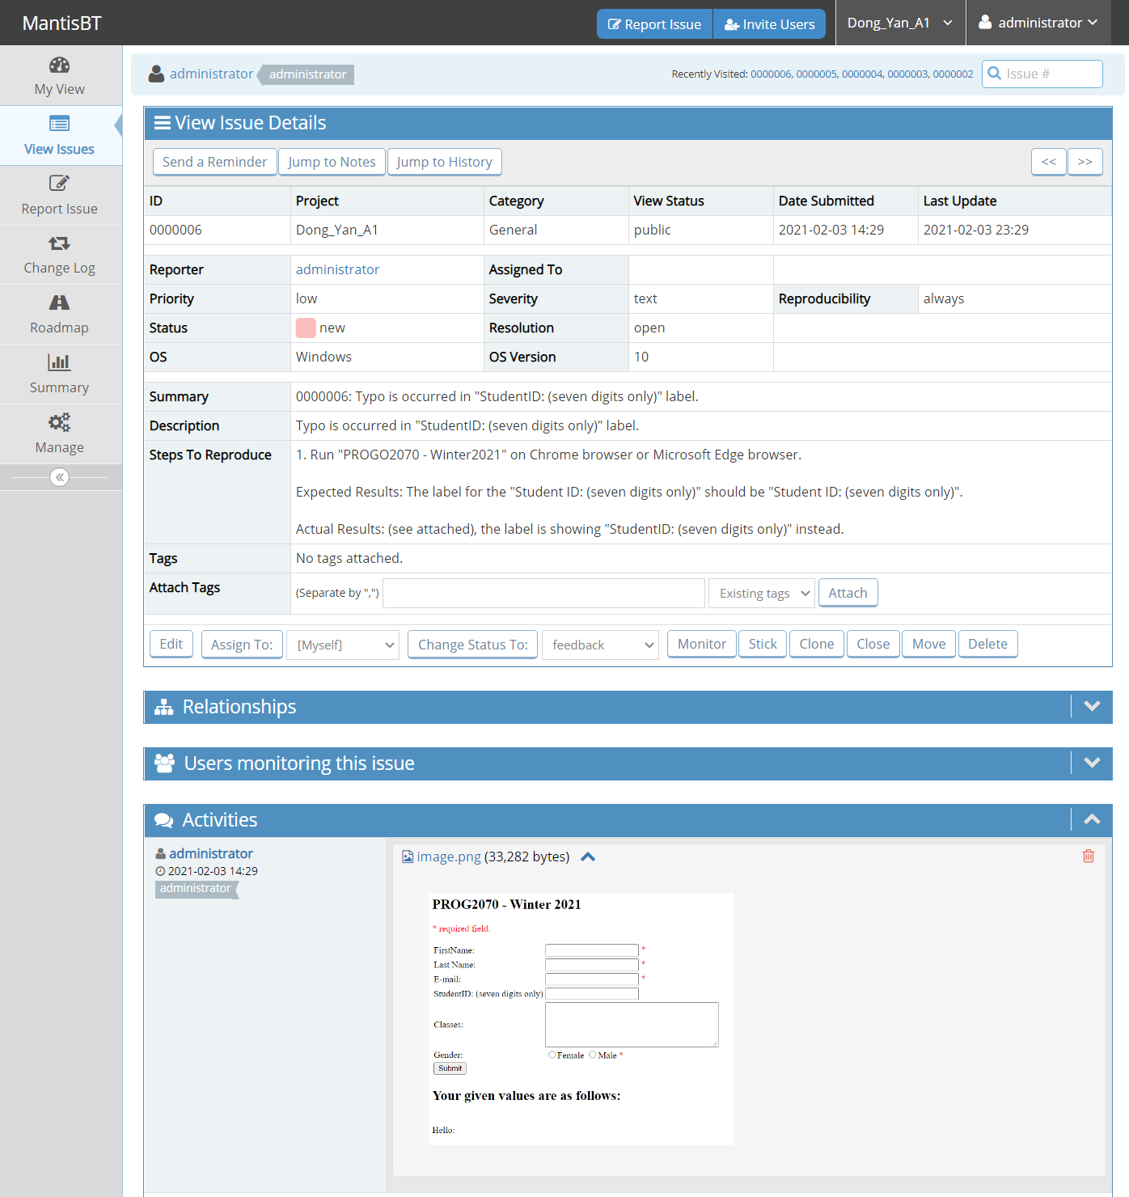

Seventh defect, the output printing area of last name isn't appropriate.

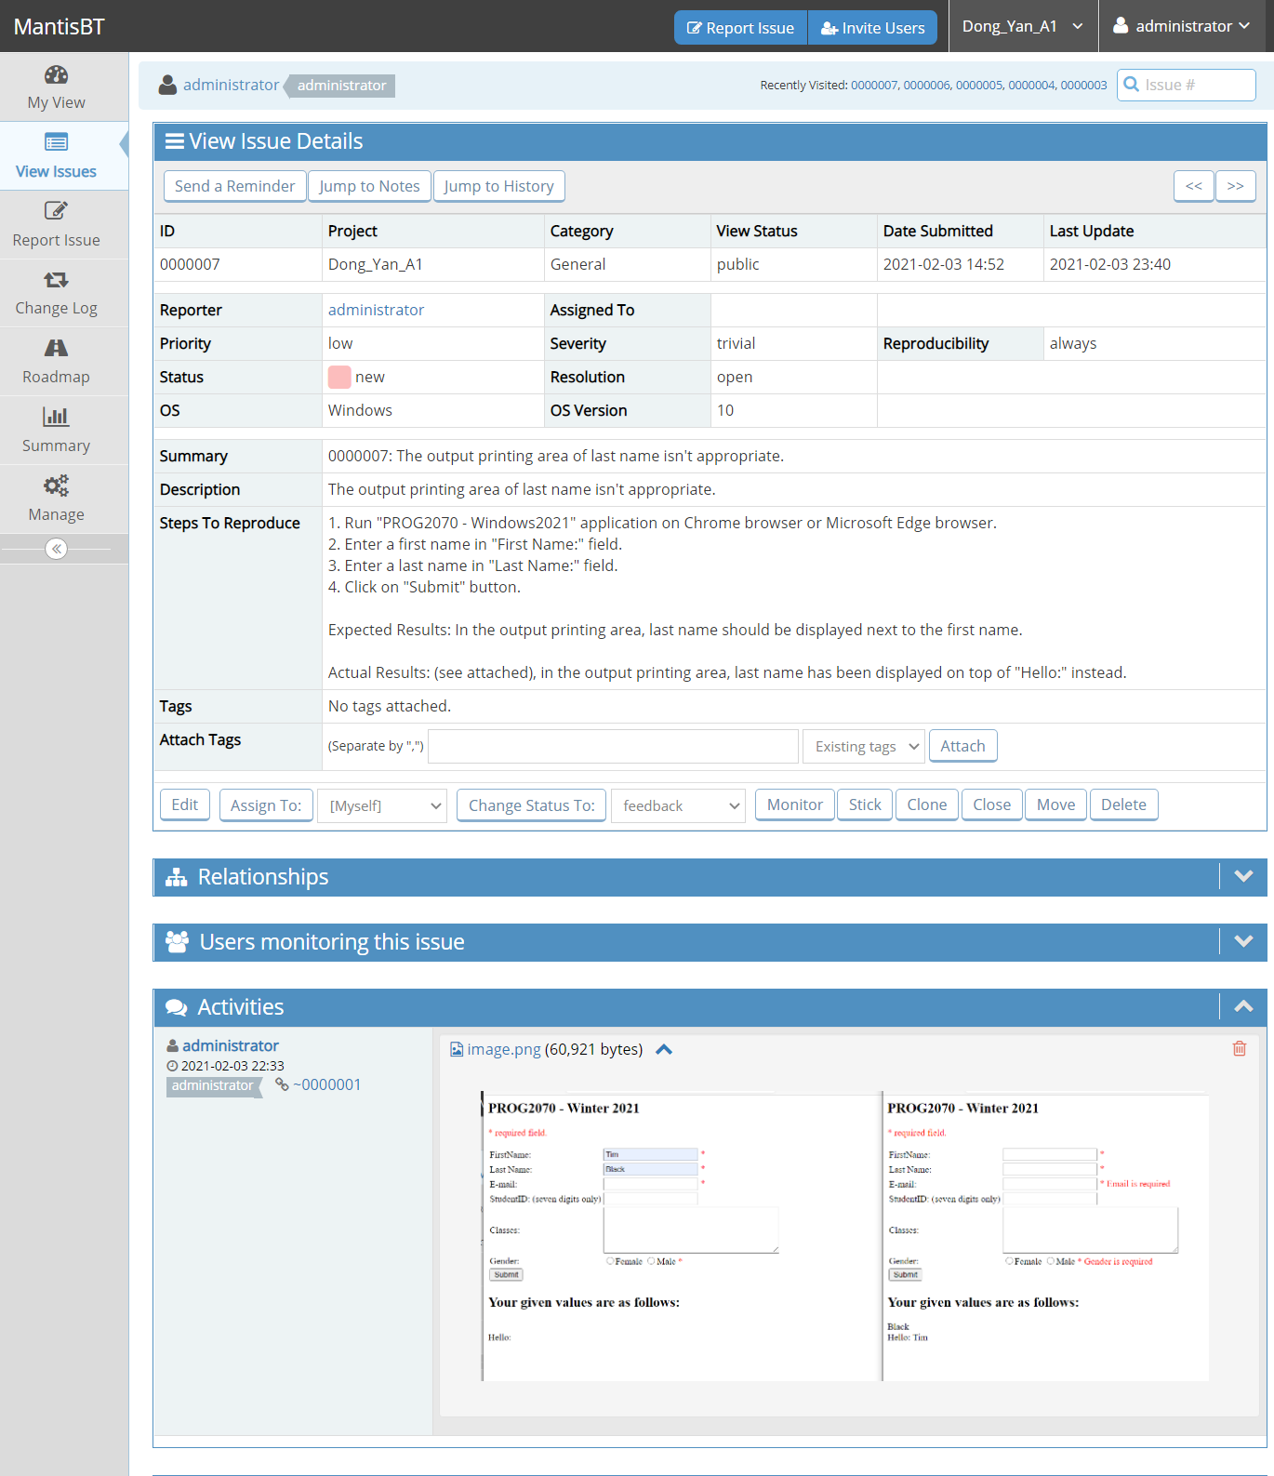

Eighth defect, "Submit" button returns value when not all the inputs are valid and/or not all the required input are filled.

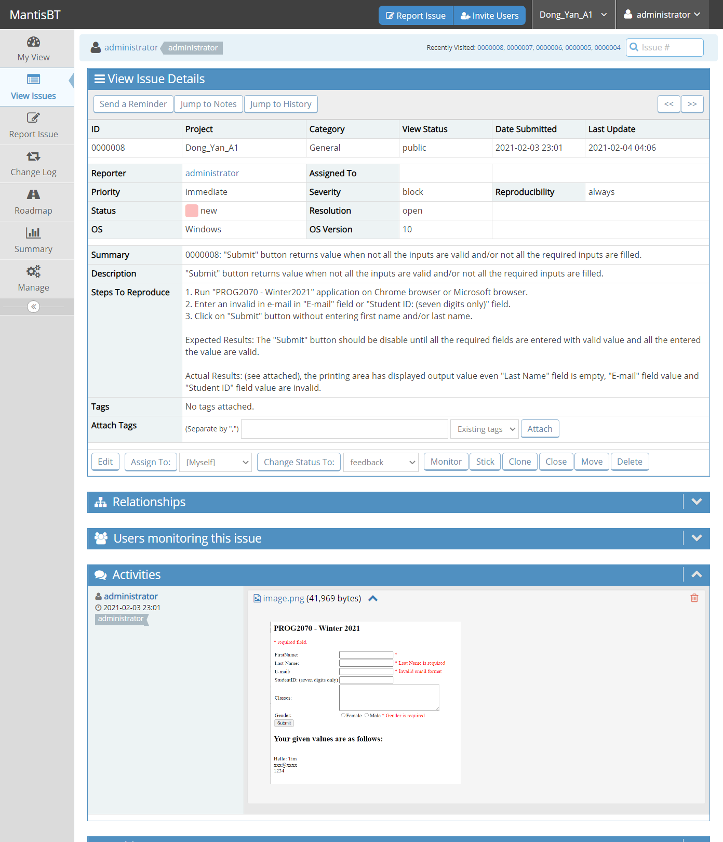

Ninth defect, an error message is displayed on the website when launch the "PROG2070 - Windows2021" application.

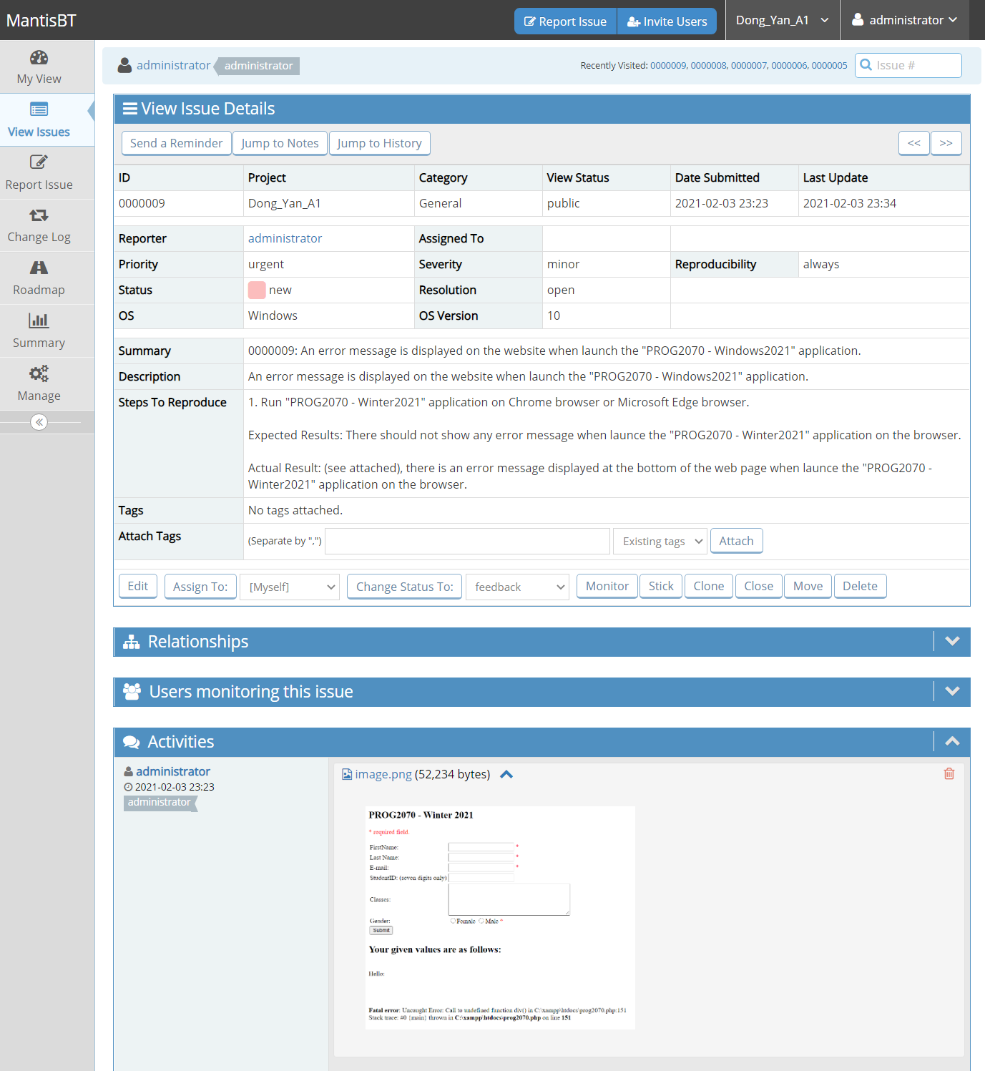

Tenth defect, the input fields are cleared after clicking "Submit" even there are invalid inputs.

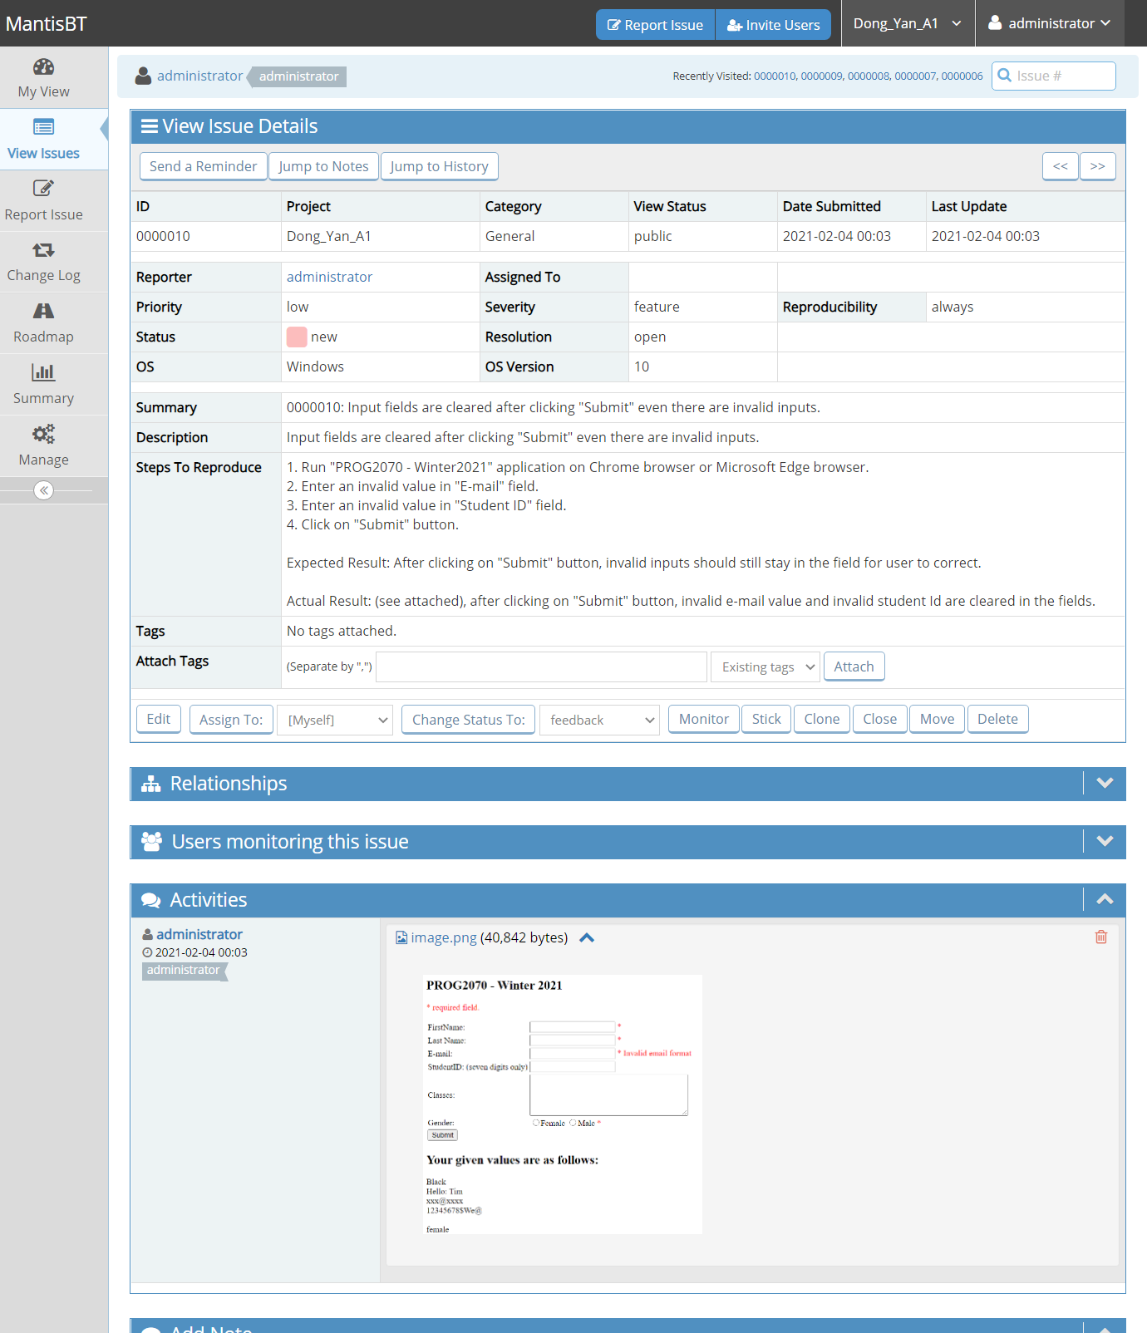

Eleventh defect, click on "Submit" button without any information in "First Name" field returns wrong error message.

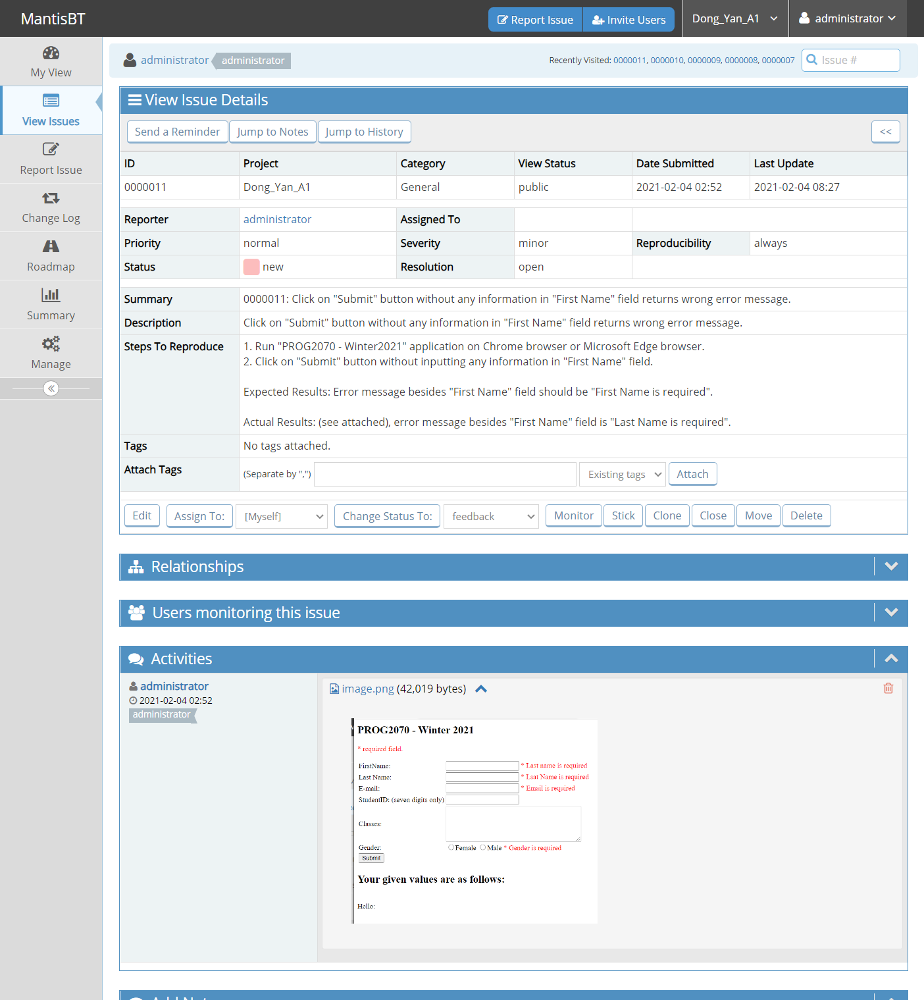

**Part II Overall view of all of the defects logged sorted by Severity**

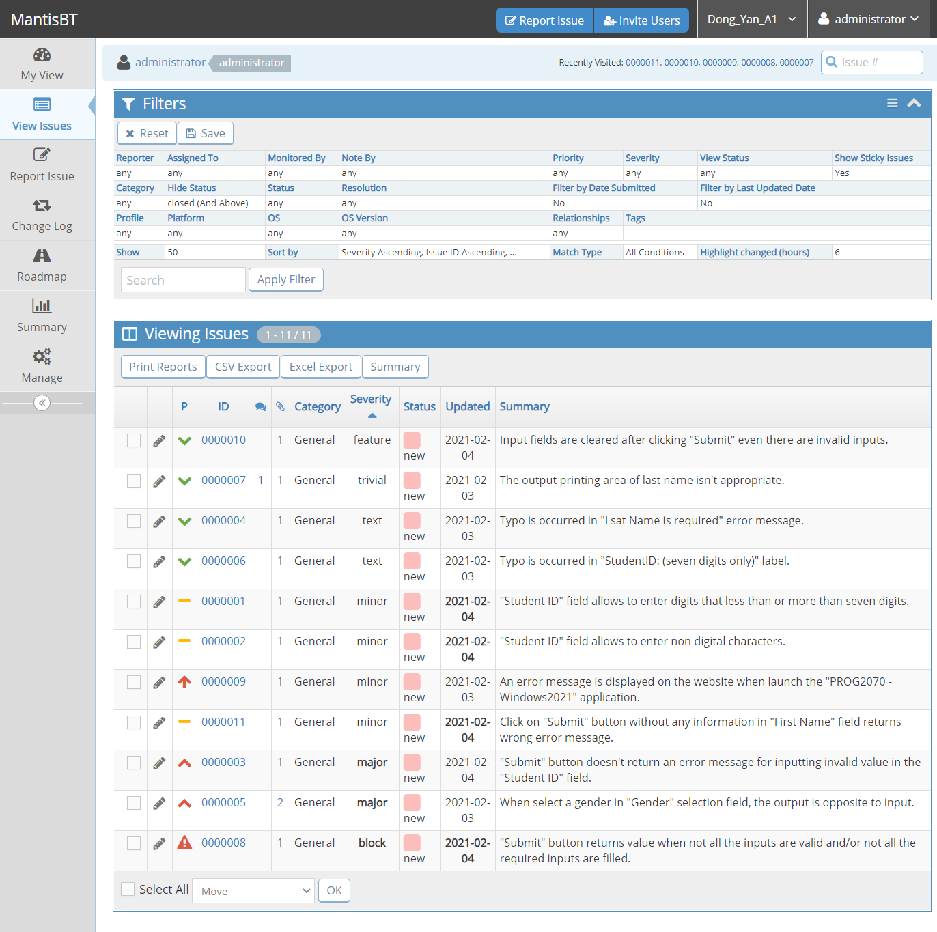

**Part III Analysis and recommendation**

First defect, “Student ID” field allows to enter digits that less than or more than seven digits. The cause of this defect is that the programmer did not limited input digits length to seven. To prevent this defect from occurring in the future, programmer could set up a minimum number equal to 10000000 and a maximum number equal to 9999999 under input tag to limit the input.

Second defect, “Student ID” field allows to enter non digital characters. The cause of this defect is that the programmer set data type to text under input tag. To prevent this defect from occurring in the future, programmer could set data type as number under input tag.

Third defect,"Submit" button does not return an error message for inputting invalid value in the "Student ID" field. The cause of this defect is that the form was submitted without validate the input value of "Student ID" field. To prevent this defect from occurring in the future, programmer could use validation rules to check if the input student Id is exactly seven digits or not before submitting the form. And displays error message if the input value violates the validation rules.

Fourth defect, typo is occurred in "Lsat Name is required" error message. The cause of this defect is due to careless typing made by programmer. To prevent this defect from occurring in the future, the programmer should double check the code spelling before submitting his work. Moreover, let other programmers to scanner over the code is also an effective way to avoid typos.

Fifth defect, when select a gender in "Gender" selection field, the output is opposite to input. The cause of this defect is that the programmer set up a wrong data value under input tag. To prevent this defect from occurring in the future, programmer should double check if the data value under input tag does match label.

Sixth defect, typo is occurred in "StudentID: (seven digits only)" label. Same as the fourth defect, the cause of this defect is due to careless typing made by programmer. To prevent this defect from occurring in the future, the programmer should double check the code spelling before submitting his work. Moreover, let other programmers to scanner over the code is also an effective way to avoid typos.

Seventh defect, the output printing area of last name is not appropriate. The cause of this defect is that the programmer is not pay attention to the web page layout. To prevent this defect from occurring in the future, programmer should read the web page line by line and think more logically about the relationship between the items on the page.

Eighth defect, "Submit" button returns value when not all the inputs are valid and/or not all the required inputs are filled. The cause of this defect is that the input fields values are displayed before each of the field applies validation rules. To prevent this defect from occurring in the future, programmer should make submission happens after all the input fields meet the requirements and pass their specific validation rule.

Ninth defect, an error message is displayed on the website when launch the "PROG2070 - Windows2021" application. The cause of this defect is that the programmer did not clear code errors before posting the web application. To prevent this defect from occurring in the future, programmer should debug the code and fix any code errors before posting the work.

Tenth defect, the input fields are cleared after clicking "Submit" even there are invalid inputs. The cause of the defect is that programmer was lack of user experience knowledge. To prevent this defect from occurring in the future, programmer should focus on users’ struggles and desires, as a result, to make the application easy to use.

Eleventh defect, click on "Submit" button without any information in "First Name" field returns wrong error message. The cause of the defect is that programmer put wrong error message. To prevent this defect from occurring in the future, programmer should double check output messages during each testing process to see if these messages are logically related.

I would not recommend this application to be released. The major and main problem with this application is that it does submit invalid input values and empty values when it shouldn’t, such as accepting non seven digits value in “Student ID” field. Moreover, “Gender” selection field reflect opposite value in output. This shows this application will save inaccurate information to the database. In addition, there are typos and inappropriate error messages which shows unprofessional behavior. Therefore, I don’t think it is good enough to release.